BIKES SALES REPORT QUERY DOCUMENT
Total Number of Orders:
SELECT COUNT(order_id) Total_Orders FROM order_items;
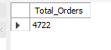
Total Number of Distinct Order_id, item_id and Product_id:
SELECT SUM(DISTINCT order_id), SUM(DISTINCT item_id), SUM(DISTINCT product_id) FROM order_items;
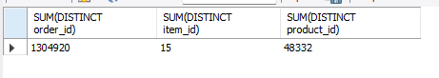
Total Order Items Revenue
SELECT CAST(SUM(list_price) AS DECIMAL(10,2)) AS TOTAL_ORDER_ITEMS_REVENUE
FROM order_items;
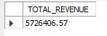
Total Products Revenue
SELECT CAST(SUM(list_price) AS DECIMAL(10,2)) AS TOTAL_PRODUCTS_REVENUE
FROM products;
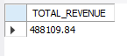
Total No of Quantity
SELECT SUM(quantity) AS TOTAL_NO_OF_QUANTITY FROM stocks;
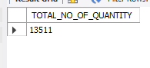

Total Number of Products by Product Name
SELECT
p.product_name,
SUM(oi.quantity) AS total_products_sold
FROM order_items oi
JOIN products p
ON oi.product_id = p.product_id
GROUP BY p.product_name
ORDER BY total_products_sold DESC
LIMIT 20;
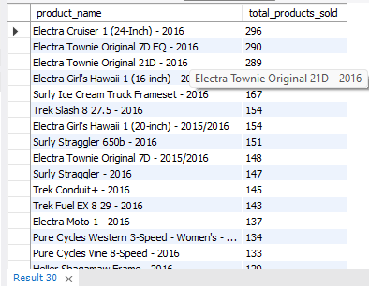

State With the Highest Number of Orders
SELECT
c.state,
COUNT(o.order_id) AS total_orders
FROM customers c
JOIN orders o
ON c.customer_id = o.customer_id
GROUP BY c.state
ORDER BY total_orders DESC
LIMIT 10;
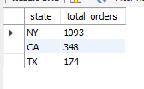
Product With The Highest Number Of Sales
SELECT
p.product_name,
SUM(oi.quantity) AS total_units_sold
FROM order_items oi
JOIN products p
ON oi.product_id = p.product_id
GROUP BY p.product_name
ORDER BY total_units_sold DESC
LIMIT 10;
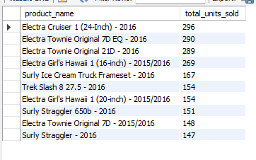
High Performing Product Brand
SELECT
b.brand_name,
SUM(oi.quantity * oi.list_price) AS total_sales_amount
FROM order_items oi
JOIN products p
ON oi.product_id = p.product_id
JOIN brands b
ON p.brand_id = b.brand_id
GROUP BY b.brand_name
ORDER BY total_sales_amount DESC
LIMIT 10;
